Girlguiding Gloucestershire
Deer Park, Cowley Booking Form
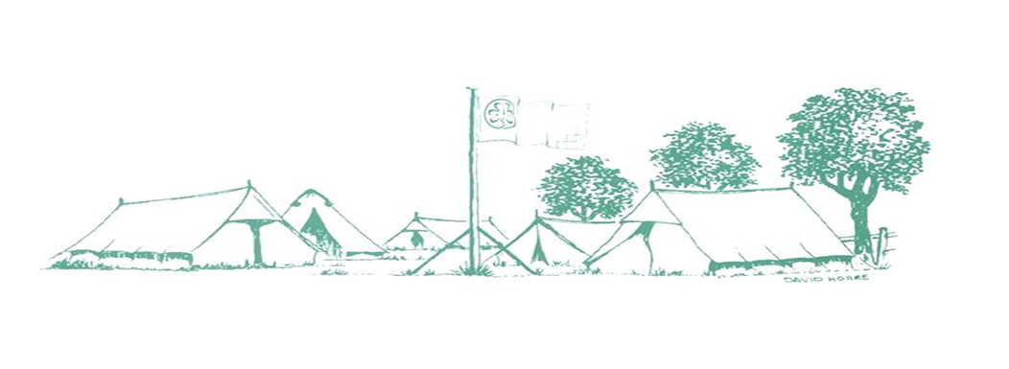
Training and Activity Centre
Girlguiding Training and Activity Centre, Deer Park, Cowley ,Cheltenham, GL53 9NJ
Tel: 01242 870284
Email: deerpark@girlguidingglos.org.uk

Please complete the form (can be completed on computer and printed and signed) and return to the Centre Manager along with the non-returnable deposit. Cheques need to be made payable to ‘Girlguiding Gloucestershire’. Receipts will be emailed once non-returnable deposit is received.

Date(s) | Click here to enter a date. | Click here to enter a date.
Accommodation Booked | Choose an item.
Non-returnable Deposit | Choose an item.

Name |  | Appointment
Address
Postcode |  | Tel No.
Email address
Unit
Division
County

Expected Numbers
Leaders |  | Rainbows
Adults (female) |  | Brownies
Adults (male) |  | Guides
Rangers/YL |  | Children
Is this a test camp

I have read and understood the booking conditions, which includes how my personal information may be used, and by signing this form agree to them
Signed
Dated

Office use
Deposit
Receipt sent

