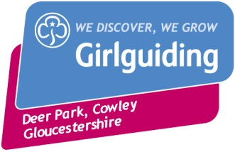
Girlguiding Gloucestershire
Deer Park, Cowley
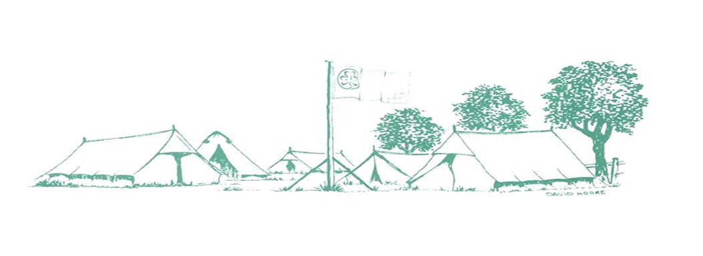
Training and Activity Centre
Girlguiding Training and Activity Centre, Deer Park, Cowley ,Cheltenham, GL53 9NJ
Tel: 01242 870284
Email: deerpark@girlguidingglos.org.uk

Booking Form for Unit ‘Bubble’ Visits 2020

Please complete one form per ‘bubble’.
By completing this booking form and returning it with your payment, you are agreeing to the Terms & Conditions for Unit ‘Bubble’ Visits 2020. Receipts will be emailed once non-returnable deposit is received.

Main Contact |  | Role:
Address
Postcode |  | Tel No.
Email address
Unit
Division
County

Details of your visit
Date
Arrival Time |  | Departure Time
Numbers
Leaders |  | Other Adults
Rainbows |  | Brownies
Guides |  | Rangers/YL
Other Children

I have read and understood the Booking Terms & Conditions for Unit ‘Bubble’ Visits 2020, which includes how my personal information may be used, and by signing this form agree to them.
Signed
Dated

