Girlguiding Gloucestershire
Deer Park, Cowley
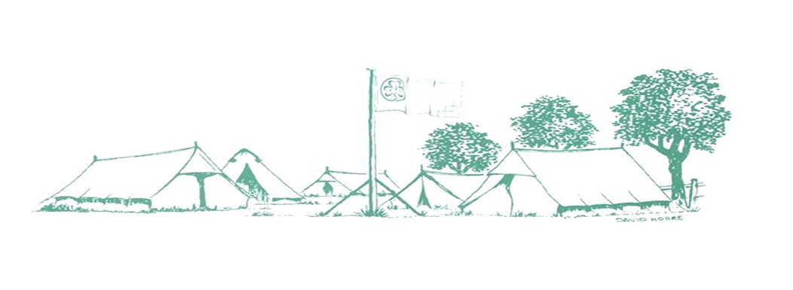
Training and Activity Centre
Girlguiding Training and Activity Centre, Deer Park, Cowley ,Cheltenham, GL53 9NJ
Tel: 01242 870284
Email: deerpark@girlguidingglos.org.uk

Booking Form for Family Self Catering 2020

By completing this booking form and returning it with your payment, you are agreeing to the Terms & Conditions for Family Self Catering 2020. Receipts will be emailed once non-returnable deposit is received.

Arrival Date |  | Departure Date
Arrival Time (after 3pm) |  | Departure Time (before 10.30am)
Contact Name |  | Membership No.
Guiding County |  | County Commissioner
Address
Postcode |  | Tel No.
Email address
No. of adults attending |  |  | No. of children
Names of all family members attending and Membership Numbers (where appropriate)

I have read and understood the Booking Terms & Conditions for Family Camping 2020, which includes how my personal information may be used, and by signing this form agree to them.
Name
Dated
Bank details for making your payment are:
Bank: CAF Bank (may show as HSBC)
Account Name: Gloucestershire Guide Association
Account Number: 00031417
Sort Code: 40-52-40

