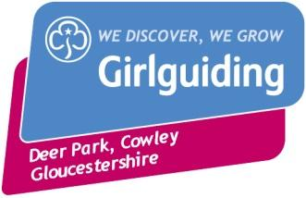
Girlguiding Gloucestershire
Deer Park, Cowley
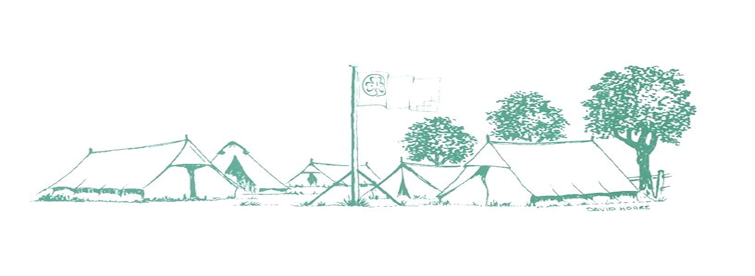
Training and Activity Centre
Tel: 01242 870284
Email: deerpark@girlguidingglos.org.uk
Girlguiding Training and Activity Centre, Deer Park, Cowley ,Cheltenham, GL53 9NJ
Booking Form for Unit ‘Bubble’ Visits 2021

Please complete one form per ‘bubble’.
By completing this booking form and returning it with your payment, you are agreeing to the Terms & Conditions for Unit ‘Bubble’ Visits 2021.

Main Contact |  | Role:
Address
Postcode |  | Tel No.
Email address
Unit
Division
County

Details of your visit
Date
Arrival Time |  | Departure Time
Numbers
Leaders |  | Other Adults
Rainbows |  | Brownies
Guides |  | Rangers/YL
Other Children

Activities booked

I have read and understood the Booking Terms & Conditions for Unit ‘Bubble’ Visits 2021, which includes how my personal information may be used, and by signing this form agree to them.
Signed
Dated

